|  |  |
| --- | --- |
|  | |
|  | |
| Heart Rhythm Abnormality Detector | |
| **Module code:** | **EG3005** |
| **Module name:** | **Third Year Project** |
|  | |
| 3rd May 2019 | |
|  | |
| **Author(s):** | **Nishat Tarannum** |
| **Student ID(s):** | **169018358** |
| **Degree:** | **MEng Software Engineering** |
| **Tutor/Project supervisor:** | **Mr. Andrew Norman** |
|  | |
| **SUPERVISOR’S COPY/EXAMINER’S COPY [For 3rd/4th year projects only - delete as appropriate]** | |

By submitting this report for assessment I confirm that this assignment is my own work, is not copied from any other person's work (published or unpublished), and that it has not previously been submitted for assessment on any other module or course.

I am aware of the University of Leicester’s policy on plagiarism, and have taken the online tutorial on avoiding plagiarism.  I am aware that plagiarism in this project report may result in the application of severe penalties up to and including expulsion from the University without a degree.

|  |
| --- |
|  |
| Summary |
| The aim of this project was to make a portable, heart rate monitor which would be able to diagnose any abnormal heartbeat patterns such as arrhythmias. This device would enable people to know immediately if they are suffering from such heart conditions without going to a doctor. The device shall be compact and easy to use to allow people of most ages to use it comfortably. This report covers the work done, decisions taken, and the various challenges faced throughout the course of the project. It further details any improvements . |

Contents

1 Introduction and Background 2

1.1 The Cardiac Cycle 2

1.2 Some types of Arrhythmias and How They Can Be Detected From an ECG 3

1.2.1 What is an Arrhythmia? 3

1.2.2 Atrial Fibrillation 3

1.2.3 Sinus Bradycardia 3

1.2.4 Sinus Tachycardia 4

1.3 Difference between ECG and PPG 4

1.3.1 Why choose PPG? 4

1.4 Heart Rate Variability 5

1.5 Why filter? 6

2 Method and Decisions 6

2.1 Pre-processing – Filtering 8

2.2 Analysis of Data 8

2.3 Cost Breakdown 10

3 Results and Findings 10

3.1 Normal Sinus Rhythm 10

3.2 Arrhythmia 11

3.3 Bradycardia and Tachycardia 12

4 Further Development 12

4.1 Analysis Improvements 12

4.2 Graphical User Interface Ideas 13

4.3 Storage and Security 14

5 Conclusion 14

References 15

Student Self-reflection on performance 17

# Introduction and Background

The aim of this project was to produce an affordable, portable device for detecting any irregularities in heart beat patterns, which includes arrhythmias. This would allow users to get immediate diagnosis of heart problems without consulting a doctor or doing an electrocardiogram (ECG). The device uses photoplethysmography (PPG) instead of ECG to gather data as this will require less equipment and thus allow people of most ages to use the device comfortably without any professional assistance.

The device was implemented using a Raspberry Pi, Arduino Micro, a photoplethysmographic (PPG) sensor and a monitor was required to see the Raspberry Pi interface.

## The Cardiac Cycle

Figure 1 below shows the normal ECG trace of a single cardiac cycle. The excitable cells of the sinoatrial node (the heart's natural pacemaker located in the upper part of the wall of the right atrium[6] shown in Figure 2) initiates the contraction of the heart muscle. At regular intervals (thus spontaneously), the sinoatrial node releases electrical stimuli which passes through the cells of the atria leading to atrial systole. This stimulus reaches the atrioventricular (AV) node and waits until the contracting atria are able to pump all the blood into the ventricles [7]. The atrioventricular valves are closed when the atria have emptied, the atria begin to refill with blood referred to as atrial diastole. At the same time, the stimulus passes through the AV node, Bundle of His down to the Purkinje fibres (these are spread across the ventricles shown in Figure 2). This causes the ventricles to contract i.e. ventricular systole. In the last part of the cycle, the ventricular muscle relaxes (referred to as ventricular diastole) and due to a pressure gradient leads to the opening of the atrioventricular valves to open and refill the ventricles with blood, restarting the cycle.

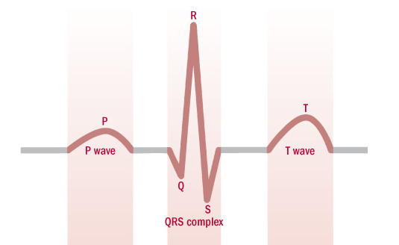 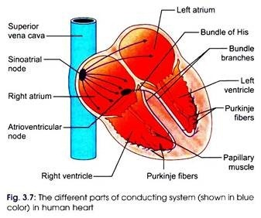

Figure 1 – ECG Trace of a Single Cardiac Cycle[3] Figure 2 - Diagram of Heart[5]

The various waves in the cycle are P waves, the QRS complex and T waves. Each wave represents a different part of cardiac cycle:

* P waves: this indicates atrial systole which is when the atria contract. In electrical terms this is atrial depolarisation where depolarisation is the release of an electrical stimulus [7].
* QRS complex: this indicates ventricular systole when the ventricles contract, shown by the large spike referred to as the R peak in Figure 1.
* T waves: indicates ventricular repolarisation (this is the recharging of the stimulus), in which the ventricles relax following depolarisation and contraction [4][7].
* A point to be noted: the atria repolarise whilst during ventricular systole, thus the atrial repolarisation is not seen on an ECG trace, it is buried in the QRS complex [7].

A normal resting heart rate for an adult is between 60 to 100 beats per minute (bpm). A lower resting heart rate means that the heart is more efficiently being able to pump blood and implies better cardiovascular fitness.

## Some types of Arrhythmias and How They Can Be Detected From an ECG

### What is an Arrhythmia?

Arrhythmias are abnormal beats. An arrhythmia is defined as a breakage of the rhythm (of the heart beat) either in timing or shape (of the ECG trace). If the shape of the ECG trace is different to a normal ECG trace, it means that the electrical activation didn’t occur in the sequence it should have. The mechanical action will also be out of sequence thus the shape of the trace will be different. This is a cardiac arrhythmia. Arrhythmias can be completely harmless or life-threatening.

### Atrial Fibrillation

In this type of arrhythmia sometimes the electrical impulses are propagated to the ventricles and the ventricles beat. Other times the atrial contraction (which are p-waves in the ECG trace [Figure 1]), is not seen because there is a limited time in which the waves can be captured. Consequently, the beat to beat timing interval in atrial fibrillation is chaotic, with no regular pattern in timing.



Figure 3 - ECG Trace of Atrial Fibrillation[8]

### Sinus Bradycardia

Bradycardia is a heart rate of anything below 60 beats per minute, however for sinus bradycardia the overall shape of the ECG trace is not changed, the heart rhythm is slowed down. Sinus Bradycardia because it is caused by the sinus node of the right atrium [11].



Figure 4 - ECG Trace of Sinus Bradycardia[9]

The R peak (large spike part of the QRS complex) intervals are regular and one P wave can be seen per QRS complex. All the waveforms can be seen clearly on the ECG trace (shown in Figure 4).

However, something to be noted is a resting heart rate of less than 60 beats per minute for particularly healthy young adults and trained athletes (they have a heart rate between 40 – 60 bpm) can be normal and, in this case, bradycardia isn’t a health problem [11].

### Sinus Tachycardia

Tachycardia is a resting heart rate of anything above 100 beats per minute, again same as sinus bradycardia the overall shape of the ECG trace is not changed. However, during exercise or if a person is experiencing stress the heart rate can go above 100 bpm and that is completely normal.



Figure 5 - ECG Trace of Sinus Tachycardia[10]

As seen previously in Figure 4, the R peak intervals are regular, and one P wave can be seen per QRS complex. All the waveforms can be seen clearly on the ECG trace in Figure 5.

## Difference between ECG and PPG

An electrocardiogram records the electrical activity of the heart using electrodes placed on the skin. The electrodes detect changes in electrical activity caused by the depolarisation of heart muscle (which controls expansion and contraction of the muscle) during each cardiac cycle [1].

However, photoplethysmography works through changes in the absorption of a low-intensity infrared (IR) green light. When light travels through organic tissues it is more strongly absorbed by blood than other tissues such as bone etc. The PPG sensor can distinguish variations in the flow of blood through this change in light intensity. The voltage signal from PPG is proportional to the quantity of blood flowing through the blood vessels. Even small changes in blood volume can be detected using this method, providing higher precision [2].

Either of the methods could have been used to measure the rate and regularity of heartbeats (which was a primary requirement for the project, in order to do analysis and detect arrhythmias).

### Why choose PPG?

ECG electrodes were not considered because for an ECG three points of different voltage are required to produce the ECG trace, and this had to be done in some form of clinical setting. Furthermore, a conducting gel has to be applied to the body to reduce resistance between skin and electrodes. This means that overall this method is less user friendly and requires other components whereas the PPG method does not need anything other than the sensor. PPG sensors are portable due to their compactness and are able to get similar results to that of ECG sensor.

## Heart Rate Variability

Healthy heart beats contain irregularities, even if the heart rate of someone is 60 beats per minute that does not mean that the heart has beaten at one second intervals. There is variation in the intervals between your heartbeats. Heart rate variability (HRV) measures the specific changes in time (or variability) between successive heart beats [12].

The time between R-peaks of the QRS complex is called an “R-R interval”, and it is measured in milliseconds as shown in Figure 6. The relationship between HRV and heart rate is inversely proportional. HRV increases when the heart rate itself is low and decreases when the heart rate is high.

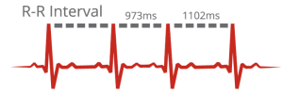

Figure 6 - R-R beat interval[12]

The simplest variable to calculate is the standard deviation of the NN intervals (SDNN), referred to as the square root of variance. This is the same as the standard deviation of the R-R intervals, same as SDSD [18].

In many studies SDNN is calculated over a 24-hour period. As the period of monitoring decreases, SDNN estimates shorter and shorter cycle lengths. It also should be noted that the total variance of HRV increases with the length of analysed recording. The most commonly used measures derived from interval differences include RMSSD, the square root of the mean squared differences of successive NN intervals, NN50, the number of interval differences of successive NN intervals greater than 50 milliseconds, and pNN50, the proportion derived by dividing NN50 by the total number of NN intervals. All of these measurements of short-term variation estimate high-frequency variations in heart rate and thus are highly correlated [17].

The formula for RMSSD is as follows:

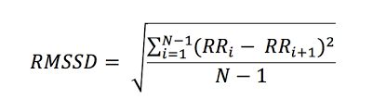

(1)

Where N is the number of samples in the signal/trace and RR is the R-R peak intervals.

The formula for SDSD/SDNN is as follows:

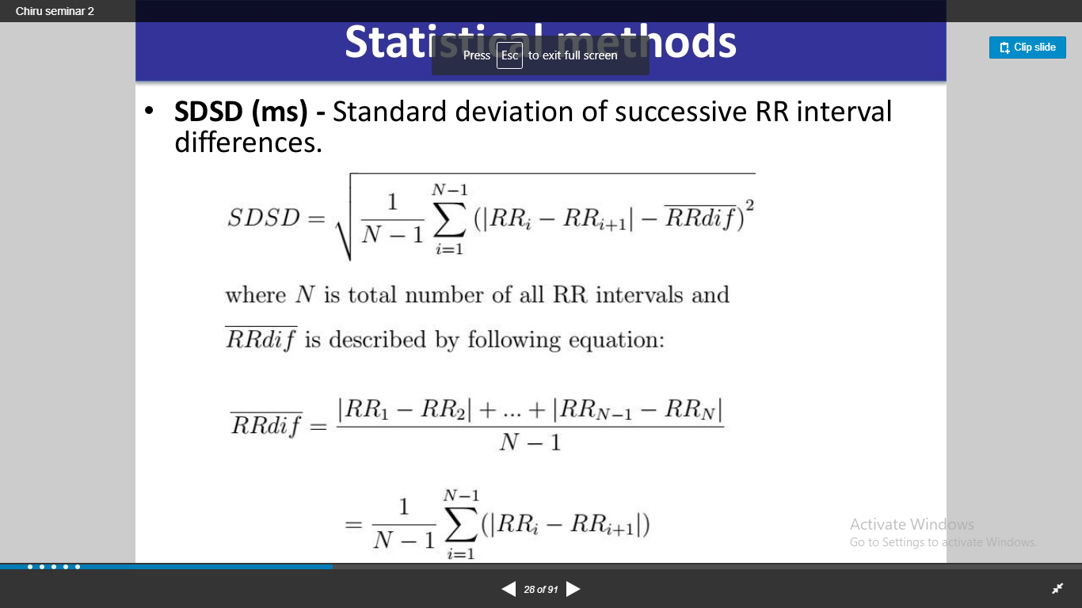

(2)

Where is the mean of the R-R peak intervals and N is the number of samples.

However, heart rate variability can be affected by factors such as age, hormones, body functions as well as lifestyle. Furthermore, women are found to have a greater heart rate variability than men [19].

Heart rate variability is high if the length of time between heart beats changes. It is low if there is not much variation. Although there are no standard accepted values that can be used to compare HRV results, it is possible to look at how the results of respondents compare to each other [20].

## Why filter?

Filtering is a process that removes unwanted components from a signal. This is especially important in these types of applications where any noise or interference could lead to incorrect peak detections and thus reduce the accuracy of heart rate measurements. Different types of filters could be used for heart rate processing. The most common filter used is the Butterworth filter as it has maximum flat frequency response in the pass band [14]. The higher the order of the filter the closer it is to an ideal filter that has unity gain (which is a gain of 1) in the passband [15].

Furthermore, low pass or bandpass filters would be best for this type of application as for an ECG trace values beyond 100Hz was not necessary for detecting arrhythmias. In a low pass filter, high frequencies are attenuated. For a band pass filter on the other hand, frequencies in a specific frequency range are able to pass through the filter. The cut-off frequency is also an important factor for filtering, it is the frequency beyond which signals will not pass through the filter [14].

# Method and Decisions

After the components had arrived, the Raspberry Pi Model 3B+ was used for processing data, which had the Raspbian operating system installed. Raspberry Pi was used as this was low cost, and compact. It is essentially a mini computer. For collecting data, an Arduino Micro was connected to a SparkFun photoplethysmographic (PPG) pulse sensor. The Arduino and the Raspberry Pi are widely available making this device easy to develop. Furthermore, if this was a commercial project then the aim would be to make the device as small as possible to allow for maximum transportability. The Arduino Micro was used because it had a built-in analogue to digital converter. The Arduino converts the value from the sensor (which is some form of analogue voltage) to an integer value. This sensor had to either be clipped to the ear lobe or wrapped around a finger using the Velcro strap provided. A diagram of the system is shown below, arrows showing what each component will be plugged into.

Figure 7 - Figure showing the connections of setup of device

Raspberry Pi

Arduino Micro

Pulse Sensor

Monitor

The pulse sensor uses photoplethysmography to measure the heart rate and this was displayed on the Arduino serial monitor using some code which was provided in an Arduino library specifically for the pulse sensor called PulseSensorPlayground. This library contains basic programs which can plot the heart rate trace and display the heart rate.

Purely for testing the functionality and quality of the pulse sensor, the provided library code was used to display the heart rate trace on the Arduino serial monitor. The sensor was quite sensitive to movement which could be seen from the trace, as trace was a bit erratic when the heart rate was measured while moving the finger. Furthermore, there was some noise visible in the signal, shown in Figure 8, below. Thus, it was decided to filter the signal before doing using the data to find any irregularities in the heart rhythm.

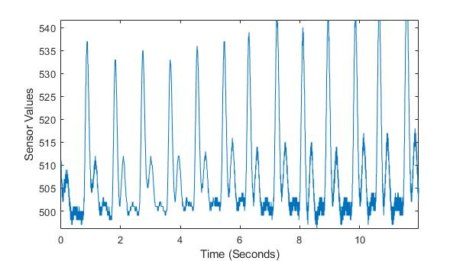

Figure 8 - Prefiltered Signal from PPG sensor showing noise

Arduino code was used to set up a timer, ensuring that every 100 Hz there is an interrupt. This was to ensure each sample was recorded at precise intervals (for more information on implementing this please refer to [16]). Then, using serial communication on the Raspberry Pi, data was sent from the Arduino and stored to a file using a Python program running on the Pi. Each integer value received was written on a new line of the file until the program was terminated or there was an error. This was done so that testing for heart rhythm problems could be done more conveniently; the file could be used as required instead of having to acquire new data each time. Once the data was written to the text file, it was then pre-processed by filtering.

## Pre-processing – Filtering

The text file including the data was converted into an array in Python, so that filtering could be done using various Python libraries such as SciPy and MatPlotLib was used for plotting the signal. A Butterworth filter was used after researching through many different filters. This was mainly done to remove noise. This would allow for detecting peaks and eventually the heart rate. A low pass Butterworth filter (the filter is used because is maximally flat magnitude response which means there are no ripples in the pass band of the filter) smoothen the signal.

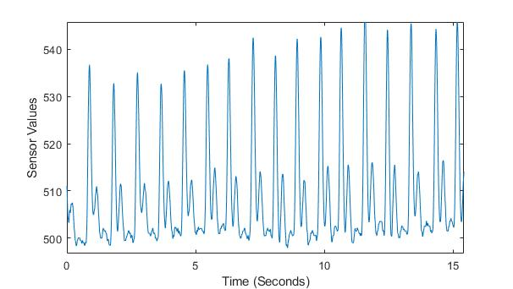

Figure 9 – Cleaner signal after filtering using a Butterworth filter

## Analysis of Data

Peaks in the signal were identified (using the R peaks in the QRS complex) to work out the heart rate. This algorithm used the sampling frequency, the array of the filtered signal and a threshold value to above which peaks were identified. E.g. the threshold value could be 530, this was dependent on the values captured in the filtered data from the sensor and the threshold should be a suitable value.

This threshold algorithm was chosen after looking at different ECG traces from an online collection of ECG traces on PhysioNet. PhysioNet is a web site which has many different physiological waveforms and it can be used by the public. As this project would have required real data, PhysioNet data was used for testing. If real data had to be obtained from a hospital, then this would be a long process with seeking permission from the department as well as some form of binding contract which would ensure that patients data does not get compromised. There would be complications which would have delayed the project. Initially, a rough estimate was made of around what y value most peaks lie and compared with other ECG traces. Depending on that, the threshold value was chosen to be a third of the difference between the maximum and minimum value of the heart trace. This gave the best results for filtered data.

The peak finding algorithm looked at each value in the filtered signal individually and checked if the current value was greater than the previous value, the next value and also greater than the threshold. If it was true, then a peak was identified, and it was added to a variable called beat_count. A few calculations were done to eventually get the beats per minute, and it was rounded to return a whole number from the function.

Next, the root mean square of the successive differences i.e. the RMSSD was calculated using the equation below:



(1)

Where N is the number of samples in the signal/trace and RR is the R-R peak intervals.

Thus, this algorithm (looking at equation 1) takes in an array of the times there is an R-peak in the filtered heart signal, then a function in the Numpy library (which is a Python library for signal processing) called diffs was used to find the time between the R-R peak intervals. Thus, solving the RRi – RRi+1 part of the equation. This finds the successive differences. These intervals were stored to an array. Then, each value in this array was squared, the values in the array were summed together to give a total value. That was then divided by the size of the array and finally square rooted giving the root mean square of successive differences.

Lastly, standard deviation of successive differences was solved using equation 2 as given below:



(2)

This algorithm takes in an array of the times there is an R-peak in the filtered heart signal. Again, the function in the Numpy library called diffs was used to find the time between the R-R peak intervals, this is the |RRi – RRi+1| part of the equation. Then the average value of this interval array was calculated by adding the elements of the array and dividing by the size of the array. This average value was stored in a variable. Next, the average value was subtracted from each value in the R-peak times array and stored in a new array called diff_with_mean. Each value in the diff_with_mean array was squared and stored in another array called squares. Eventually, the elements of the squares array were added together and divided by the size of the array to get the mean and finally this was square rooted.

Lastly, it was chosen that bradycardia and tachycardia as seen from research are clinically said to be a heart rate less than 60 bpm and a heart rate more than 100 bpm respectively. But, as some more fit individuals may have a lower heart rate, so this value was changed to 55 bpm for Bradycardia detection.

## Cost Breakdown

A budget of £150 was given and the total amount of money spent in implementing this project was £95.72. The main aim was to make this device affordable, easy to use for most adults and setup. The total costs of the project are given below in Table 1:

Table 1 - Showing a breakdown of the costs

|  |  |  |
| --- | --- | --- |
| Item | Price (£) | Seller |
| Raspberry Pi 3B+ Starter Kit | 49.67 | Farnell element14 |
| Arduino Micro | 13.28 | Rapid Electronics |
| HDMI to DVI cable (for connecting to monitor) | 6.65 | Rapid Electronics |
| Breadboard | 7.24 | Rapid Electronics |
| Sparkfun Sensor | 18.88 | Mouser Electronics |
| Total | 95.72 |  |

# Results and Findings

PhysioNet data was used for the testing of this device. The data was quite noisy most of the time which is why many different traces were not able to be used. Even after filtering there was too much noise, so the peak detection algorithm was finding more peaks than it should have. More testing of signals was desired to give a better average of heart rate variability measures of people suffering from some form of arrhythmia and someone who has a normal sinus rhythm. All RMSSD and SDSD values are in seconds.

## Normal Sinus Rhythm

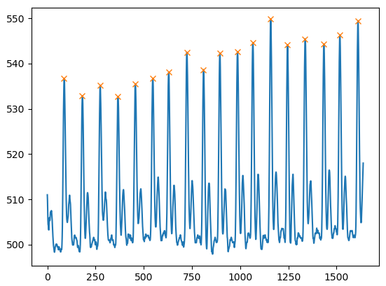

Figure 10 - Normal Sinus Rhythm Peaks using ECG Figure 11 - Normal Sinus Rhythm Peaks using PPG

The peak detection algorithm is working correctly as can be seen by the crosses on the Figures above. For Figure 10, the heart rate was 60 bpm, RMSSD value was 0.9688 and the SDSD value was 3.4523. Figure 11 is a reading from the PPG device and the heart rate was 66 bpm, RMSSD values for that was 0.8984 and SDSD was 6.4012.

## Arrhythmia

As most of the signals from PhysioNet were very noisy much analysis was not able to be conducted. Some readings were very wrong, some examples are shown below. Extra peaks were detected due to the abnormality of the trace and the amount of noise.

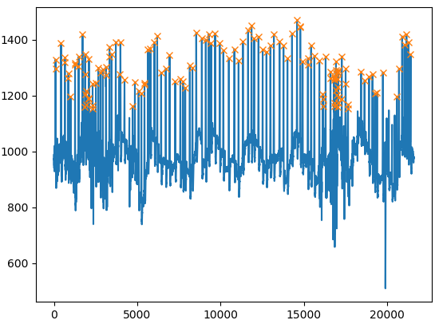 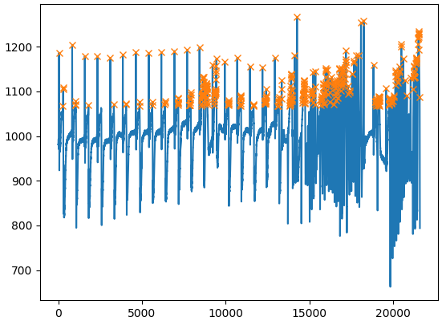

Figure 12 – Arrhythmia ECG trace with noise Figure 13 – Arrhythmia ECG trace with noise

The algorithm for peak detection completely fails if too much noise is present it is unable to distinguish between peaks properly.

For Figure 12, the heart rate was 134 bpm, RMSSD value was 0.5887 and the SDSD value was 23.8377. In Figure 13 the heart rate was 381 bpm, RMSSD values for that was 0.3841 and SDSD was 33.2190.

The heart beat values are very inaccurate however the fact that these two people have arrhythmias is still possible to be detected as the bpm is very high (although this is because the peak detection is not working correctly) the device will detect this as an abnormality, it will say this is some form of tachycardia. The people may not be suffering from tachycardia, but both are suffering from some form of arrhythmia and they do not have a normal sinus rhythm. Even the RMSSD values are seen to be much lower than they were for people with a normal sinus rhythm. However, the SDSD values were much greater by at about 4 times as much if the PPG trace is used as a reference.

## Bradycardia and Tachycardia

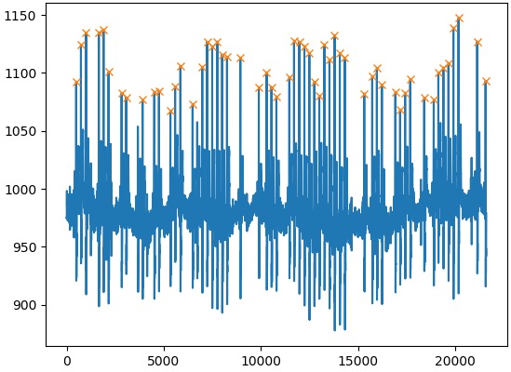 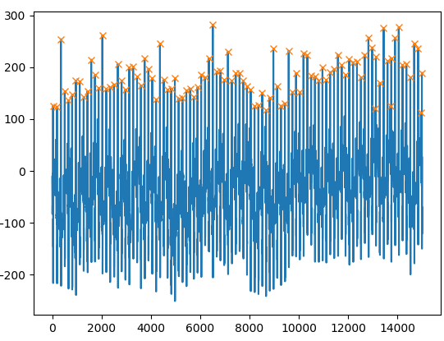

Figure 14 – Example of bradycardia Figure 15 – Example of tachycardia

In the tachycardia ECG trace, a few extra peaks were detected near the end however yes, this person was suffering from tachycardia.

For Figure 14, the heart rate was 55 bpm, RMSSD value was 1.1978 and the SDSD value was 24.7558. In Figure 15 the heart rate was 101 bpm, RMSSD values for that was 0.6078 and SDSD was 24.8667.

However, these two traces support the idea that was shown in the arrhythmia traces. The SDSD value is much larger than for a regular sinus rhythm. Overall, the peak detection algorithm seems to be working quite well in for these two cases, bar the 2/3 extra peaks in the tachycardia trace. However, it seems for the bradycardia case, there is a much higher RMSSD value than for a normal sinus rhythm and for tachycardia it is much lower than normal.

Thus, from these results, it can be concluded that RMSSD values are higher for people with a normal heart rhythm and this measure can be used to detect arrhythmias, except for the case of bradycardia. For bradycardia, the main thing that can be used for diagnosis is the heart rate and the SDSD value, as this is much higher for an individual suffering from bradycardia. The SDSD value is more reliable it seems as for each case of arrhythmia the value was much larger than for a person with a normal sinus rhythm. So, this measure can be used to detect for some sort of arrhythmia if the value is above approximately 15 seconds. RMSSD value can be used as well but this measure should be used after checking that a person does not have bradycardia.

# Further Development

## Analysis Improvements

From research conducted it was seen that using a longer period of time to collect data, gave more reliable results for the RMSSD. New devices that measure heart rate variability record data for about a period of around 5 mins. This gives more reliable results when parameters such as RMSSD and SDSD are analysed. Thus, instead of recording data for around 1 minute, a longer time period should be used for a better understanding of a person’s heart health. More insight into other heart rate variability measures (such as pNN50) would also make the project more concrete and would help in finding more direct links between variability and arrhythmias.

It would also be useful if a more accurate and clean signal was able to be produced from the PPG sensor so that not only the R peaks were used to do analysis but other waves could be identified more clearly allowing the device to not only detect arrhythmias but to be able to distinguish between atrial fibrillation and other tachycardias for example. However, this might be difficult as the PPG sensor is not able to produce a heart trace as well as an ECG, so the performance has to be compromised for the equipment used.

In addition, it would be more useful if the processing of data could be done at the same time as the data is stored instead of the user having to find the program on the Raspberry Pi and running the analysis manually. So that the user could be able to see live analysis of their data, this would be possible if instead a moving average algorithm was used to calculated heart rate.

An idea which was discussed but wasn’t implemented due to time constraints was to find the width at half the height of the R peak, as arrhythmias are a change in shape of the heart shape, another algorithm would have looked at the length of a QRS complex, and if the length of time taken was long or irregular then an arrhythmia could have been detected. Variation in heart beat rhythm is good however, if the time of the QRS complex is very long and then suddenly is much shorter there may be underlying problems.

## Graphical User Interface Ideas

A graphical user interface (GUI) was made for the program to run analysis, however this was made using tkinter which is a standard Python interface to make GUIs. The interface is given below.

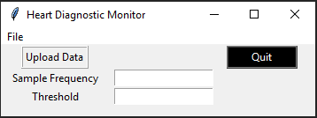

Figure 16 - Interface of GUI

This was coded before the threshold algorithm was made, thus the threshold had to be chosen by the user, which was not at all ideal. The user however does have to input a sample frequency, but this will not be needed now as the Arduino is sampling at 100Hz and that was the chosen frequency. So, the sampling frequency would be set to 100.

When the “Upload Data” button was pressed, a dialogue box opens up to the current directory and the GUI expects a text file to be uploaded.

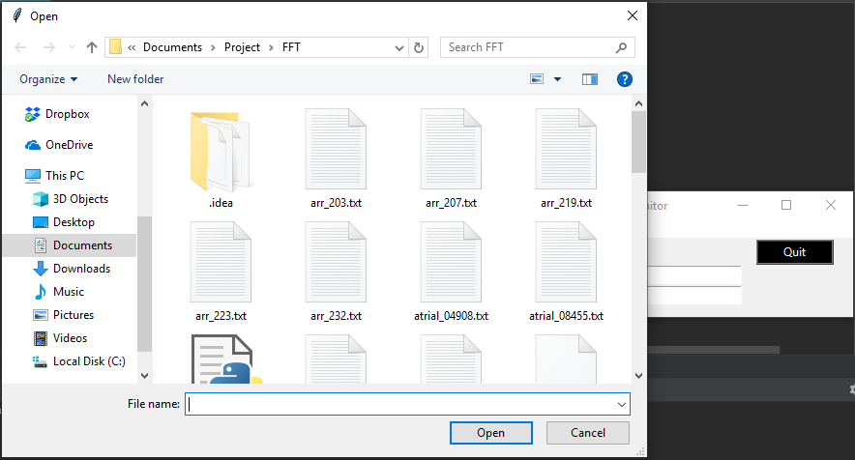

Figure 17 – When Upload button is pressed

The “Quit” button exits the program and there is also a drop-down menu from “File” to exit.

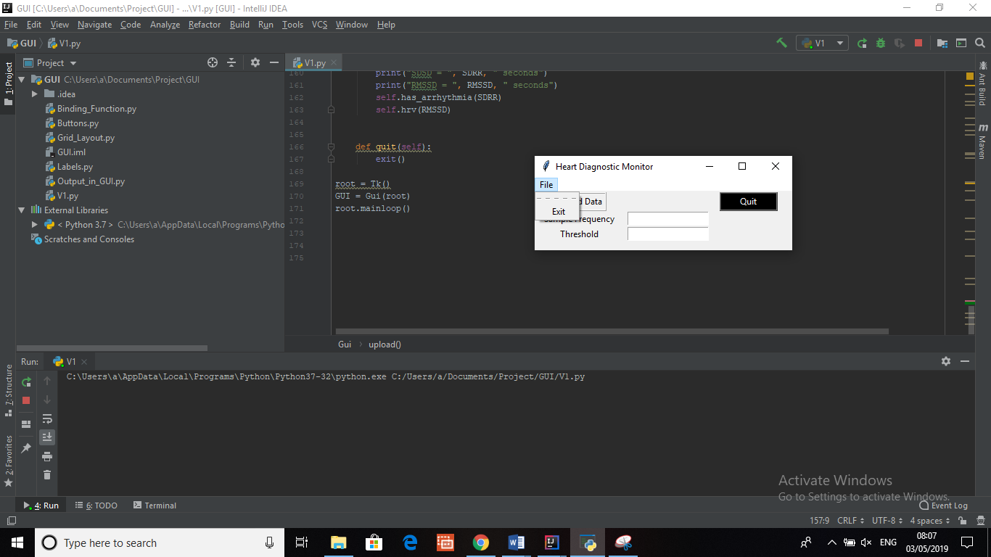

Figure 18 – When File menu button is pressed

There were some drawbacks to using tkinter. It does not look very professional and looks very much like Windows XP. Secondly, the output of the results was on the console of the Python IDE which was not the best. The only thing that could be used were message boxes however they don’t seem to be suitable. There are newer GUI toolkits such as PyQt which was considered when the GUI was coded but that would’ve taken some time and there was not enough information regarding the newer version of PyQt. Thus, the plan to make the GUI look nicer was for the time being scrapped. However, this can be developed and would surely be a better way for users to use the device as it would look more appealing and easier to use instead of having to use the Python IDE.

## Storage and Security

Initially, it was thought to make an online web application maybe using frameworks such as Django (this is for Python web applications). This was later thought of as not a good idea as this device would have sensitive data and it would be not be ideal if a user’s data was leaked online. It would definitely have to be secure by encryption. The data would be stored in some sort of session database (which saves each time the person records data as a session) and then this would be able to be accessed by the user through their own account to a website. The database would be a SQL database which is the most commonly used language. Furthermore, the SQL database could be connected to a server and users would be able to access their data online via an app or a website similar to the Fitbit. And they would be able to track their data anywhere and anytime.

# Conclusion

From the results seen, heart rate variability measures can be used to find correlations in problems in heart rhythms and thus, this device has the ability to distinguish between a healthy heart rhythm and an abnormal one as well as distinguish between arrhythmias, bradycardias and tachycardias. Although heart rate variability itself is unique to each person, correlations can be seen between people suffering from arrhythmias and heart rate variability measures such as RMSSD.

Someone suffering from arrhythmia is shown to have an average RMSSD value of around 0.6 seconds or lower (seen from the results). Furthermore, people who have a normal sinus rhythm are seen to have higher RMSSD values averaging around 0.9 seconds thus concluding that heart rate variability is higher for healthier hearts, but bradycardia is an exception. In which case, the heart rate is a more important measure. However, SDSD can be used to as a better measure which can classify between normal sinus rhythm and an arrhythmia. It was chosen that a value of SDSD above 15 seconds would mean a person was suffering from arrhythmia. Thus, it can be this device can to a certain degree detect abnormalities in heart beat patterns if a filtered signal is input into the device using heart rate variability statistics. However, as much analysis has not been able to be conducted due to the nature of the traces it more research and a better algorithm may be needed to be able to say this device is very good at its job. The signal input into the device cannot be noisy otherwise the algorithms for finding heart rate and other measures do not work and give inaccurate results.

However, as this device will be using PPG and the testing of the algorithms was done using ECG traces from PhysioNet, this should not be a problem as the PPG gave quite a clean signal after filtering. The main drawback with PPG is that it cannot completely replace an ECG and there will be more inaccuracies. More complex arrhythmias which have complicated shapes will probably not be able to be distinguished on this device. In addition, people who are suffering from multiple heart problems also may face issues in getting correct results as the device made so far is unable to handle very complex signals.

Lastly, there is however scope for PPG to become more widely used and in some cases, it may replace ECG due to its ease of use and reasonably accurate reading capabilities. And projects such as this can be developed to do more comprehensive analysis.

References

[1] En.wikipedia.org. (2019). *Electrocardiography*. [online] Available at: https://en.wikipedia.org/wiki/Electrocardiography [Accessed 23 Apr. 2019].

[2] Soulfit Blog. (2019). *How Does PPG Technology Works? - SoulFitBlog*. [online] Available at: https://soulfit.io/blog/how-does-ppg-technology-works/ [Accessed 23 Apr. 2019].

[3] Publishing, H. (2019). *Understanding the ECG: Reading the waves - Harvard Health*. [online] Harvard Health. Available at: https://www.health.harvard.edu/heart-health/understanding-the-ecg-reading-the-waves [Accessed 23 Apr. 2019].

[4] Courses.lumenlearning.com. (2019). *Physiology of the Heart | Boundless Anatomy and Physiology*. [online] Available at: https://courses.lumenlearning.com/boundless-ap/chapter/physiology-of-the-heart/ [Accessed 25 Apr. 2019].

[5] S, S. (2019). *Conducting System of Human Heart (With Diagram).* [online] Biology Discussion. Available at: http://www.biologydiscussion.com/human-physiology/cardiovascular-system/conducting-system-of-human-heart-with-diagram/62414 [Accessed 25 Apr. 2019].

[6] William C. Shiel Jr., F. (2018). *Definition of SA node*. [online] MedicineNet. Available at: https://www.medicinenet.com/script/main/art.asp?articlekey=5402 [Accessed 25 Apr. 2019].

[7] Nottingham.ac.uk. (2019). *Cardiac Conduction System - Normal Function of the Heart - Cardiology Teaching Package - Practice Learning - Division of Nursing - The University of Nottingham*. [online] Available at: https://www.nottingham.ac.uk/nursing/practice/resources/cardiology/function/conduction.php [Accessed 25 Apr. 2019].

[8] Healio.com. (2019). *Atrial Fibrillation ECG Review - Criteria and Examples | LearntheHeart.com.* [online] Available at: https://www.healio.com/cardiology/learn-the-heart/ecg-review/ecg-topic-reviews-and-criteria/atrial-fibrillation-review# [Accessed 30 Apr. 2019].

[9] Healio.com. (2019). *Sinus Bradycardia ECG Review - Criteria and Examples | LearntheHeart.com.* [online] Available at: https://www.healio.com/cardiology/learn-the-heart/ecg-review/ecg-topic-reviews-and-criteria/sinus-bradycardia-review [Accessed 30 Apr. 2019].

[10] Healio.com. (2019). *Sinus Tachycardia ECG Review - Criteria and Examples | LearntheHeart.com*. [online] Available at: https://www.healio.com/cardiology/learn-the-heart/ecg-review/ecg-topic-reviews-and-criteria/sinus-tachycardia-review [Accessed 30 Apr. 2019].

[11] En.wikibooks.org. (2018). *Exercise as it relates to Disease/Bradycardia in athletes - Wikibooks, open books for an open world*. [online] Available at: https://en.wikibooks.org/wiki/Exercise_as_it_relates_to_Disease/Bradycardia_in_athletes [Accessed 30 Apr. 2019].

[12] Moore, J. (2019). *Heart Rate Variability vs. Heart Rate*. [online] Heart Rate Variability Educational Courses. Available at: https://hrvcourse.com/heart-rate-variability-vs-heart-rate/ [Accessed 1 May 2019].

[13] Ouraring. 2017*. What Is Heart Rate Variability And What Can You Learn From It.* [online] Available at: https://ouraring.com/heart-rate-variability-basics/. [Accessed 1 May 2019].

[14] Wikipedia. 2019. *Filter (signal processing).* [online] Available at: https://en.wikipedia.org/wiki/Filter_(signal_processing). [Accessed 1 May 2019].

[15] StackExchange. 2016. *Higher Order Butterworth Filters.* [online] Available at: https://dsp.stackexchange.com/questions/34127/higher-order-butterworth-filters. [Accessed 1 May 2019].

[16] Instructables.com. (2019). [online] Available at: https://www.instructables.com/id/Arduino-Timer-Interrupts/ [Accessed 1 May 2019].

[17] Ahajournals.org. (2019). *Heart Rate Variability | Circulation*. [online] Available at: https://www.ahajournals.org/doi/full/10.1161/01.cir.93.5.1043 [Accessed 2 May 2019].

[18] HRV, E. (2019). *What are HRV score, RMSSD, ln(RMSSD), SDNN, NN50, and PNN50? - Elite HRV Knowledge Base*. [online] Help.elitehrv.com. Available at: https://help.elitehrv.com/article/68-what-are-hrv-score-rmssd-ln-rmssd-sdnn-nn50-and-pnn50 [Accessed 2 May 2019].

[19] Oura Ring. (2019). *What Is Heart Rate Variability And What Can You Learn From It | Oura Ring*. [online] Available at: https://ouraring.com/heart-rate-variability-basics/ [Accessed 2 May 2019].

[20] Bryn Farnsworth, P. and Krosschell, K. (2019). *Heart Rate Variability - How to Analyze ECG Data*. [online] iMotions. Available at: https://imotions.com/blog/heart-rate-variability/ [Accessed 3 May 2019].

Student Self-reflection on performance

All students must complete the following sections for every piece of work they submit using this template. The aim of this is to help you use feedback more effectively to improve your marks and your skills as a professional engineer. This section is not formally marked, but your tutor may use it when discussing your work with you.

|  |
| --- |
| Describe how you have used AT LEAST ONE of the following sources of information to improve this piece of work:  1.) (PREFERRED) Feedback from previous assignment(s). This can be from the same module or from a previous module or previous year of study (e.g. comments from 1st year lab formal reports should be used to help improve your 2nd year lab formal reports).  2.) The marking criteria or rubric provided for this assignment.  3.) The Department Technical Writing Handbook for Students. |
| Feedback from the interim report has supported in writing this report. Furthermore, the technical writing handbook also supported in referencing. |
| Are there any aspects of this work that you would specifically like the marker to comment/or advise on? For example: “I wasn’t sure if my figure formatting looked professional and would appreciate feedback on this aspect” |
| I wasn’t sure if I have written enough about my project as a whole and if more background information was required, I would like some feedback on this. Thank you. |